**LABWORK 8**

**Task 1**

CODE

INDEX HTML

<!DOCTYPE html>

<html lang="en">

<head>

<meta charset="UTF-8">

<meta name="viewport" content="width=device-width, initial-scale=1.0">

<title>ABC, Inc. Year End Budget Summary</title>

<link rel="stylesheet" href="style.css">

</head>

<body>

<h1>Welcome to HTML</h1>

</body>

</html>

STYLES CSS CODE

body{

font-family: Verdana, Arial, Helvetica, sans-serif;

font-size: 12px;

background-color: #CCFFFF;

}

h1{

font-size: 14px;

font-variant: small-caps;

color: #FF0000;

background-color: #00FF00;

}

OUTPUT

TASK 2

CODE

<!DOCTYPE html>

<html lang="en">

<head>

<meta charset="UTF-8">

<meta name="viewport" content="width=device-width, initial-scale=1.0">

<title>Budget Summary</title>

<link rel="stylesheet" href="style.css">

</head>

<body>

<div id="budgetsummary">

<p>This is the budget summary for ABC, Inc. In the Year 2005, we had an income of

<span class="income">$74,935</span>. We had expenses of

<span class="expence">$41,167</span>. This allowed us to have a profit of

<span class="profit">$33,768</span>.

</p>

<p>In 2000, we had an income of<span class="income">$50,123</span>and expenses of

<span class="expence">$30,796</span>. This allowed us to have a profit of

<span class="profit">$19,327</span>.

</p>

<p>In 1995, we had an income of <span class="income">$35,182</span> and expense of

<span class="expence">$29,772</span>. for a total profit of

<span class="profit">$5,410</span>.

</p>

<p>In 1990, we had an income of <span class="income">$20,031</span> and expenses of

<span class="expence">$19,271</span>. for a total profit of

<span class="profit">$760</span>.

</p>

<p>As you can see, we ate constantly growind=g. As we move further into the 21st

century, at ABC Inc. we think the future is bright!</p>

</div>

</body>

</html>

STYLE CSS CODE

body {

font-family: Verdana, Arial, Helvetica, sans-serif;

background-color: #CCFFFF;

}

h1 {

font-size: 14px;

font-variant: small-caps;

color: #FF0000;

background-color: #00FF00;

}

p:first-letter {

font-size: 200%;

font-family: Helvetica, sans-serif;

font-variant: small-caps;

color: #FF0000;

}

.income {

background-color: #CCCCCC;

}

.expenses {

background-color: #FF0000;

}

.profit {

background-color: #FFFF00;

}

#budgetsummary {

background-color: #FFFFFF;

border: 1px dotted;

}

OUTPUT

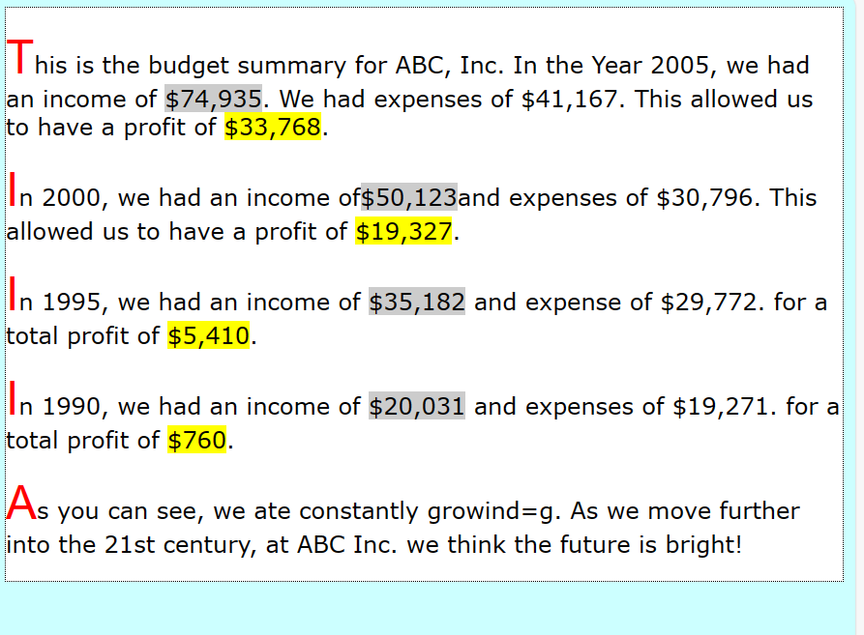

TASK 3

CODE

<!DOCTYPE html>

<html lang="en">

<head>

<meta charset="UTF-8">

<meta name="viewport" content="width=device-width, initial-scale=1.0">

<title>Budget Summary</title>

<link rel="stylesheet" href="style.css">

</head>

<body>

<div id="budgetsummary">

<p>This is the budget summary for ABC, Inc. In the Year 2005, we had an income of

<span class="income">$74,935</span>. We had expenses of

<span class="expence">$41,167</span>. This allowed us to have a profit of

<span class="profit">$33,768</span>.

</p>

<p>In 2000, we had an income of<span class="income">$50,123</span>and expenses of

<span class="expence">$30,796</span>. This allowed us to have a profit of

<span class="profit">$19,327</span>.

</p>

<p>In 1995, we had an income of <span class="income">$35,182</span> and expense of

<span class="expence">$29,772</span>. for a total profit of

<span class="profit">$5,410</span>.

</p>

<p>In 1990, we had an income of <span class="income">$20,031</span> and expenses of

<span class="expence">$19,271</span>. for a total profit of

<span class="profit">$760</span>.

</p>

<p>As you can see, we ate constantly growind=g. As we move further into the 21st

century, at ABC Inc. we think the future is bright!</p>

</div>

</body>

</html>

STYLE CSS CODE

body {

font-family: Verdana, Arial, Helvetica, sans-serif;

background-color: #CCFFFF;

}

h1 {

font-size: 14px;

font-variant: small-caps;

color: #FF0000;

background-color: #00FF00;

position: absolute;

top: 0;

left: 0;

}

p:first-letter {

font-size: 200%;

}

.income {

background-color: #CCCCCC;

}

.expenses {

background-color: #FF0000;

}

.profit {

background-color: #FFFF00;

}

#budgetsummary {

background-color: #FFFFFF;

border: 1px dotted;

padding: 20px;

width: 500px;

position: absolute;

bottom: 0;

font-size: 12px;

}

OUTPUT

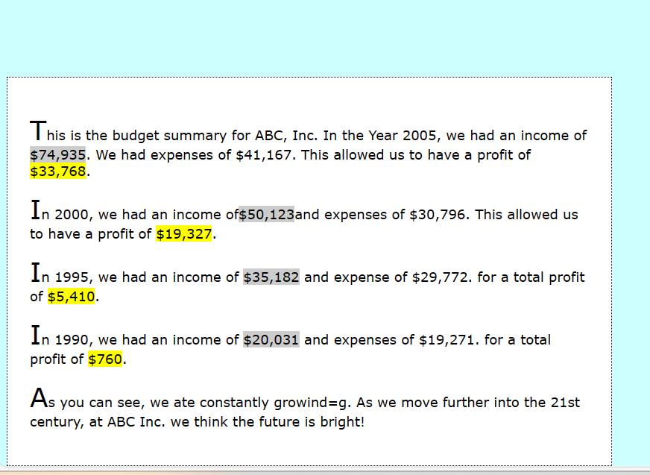

TASK 4

CODE

<!DOCTYPE html>

<html lang="en">

<head>

<meta charset="UTF-8">

<meta name="viewport" content="width=device-width, initial-scale=1.0">

<title>Budget Summary</title>

<link rel="stylesheet" href="style.css">

</head>

<body>

<div id="budgetsummary">

<p>This is the budget summary for ABC, Inc. In the Year 2005, we had an income of

<span class="income">$74,935</span>. We had expenses of

<span class="expence">$41,167</span>. This allowed us to have a profit of

<span class="profit">$33,768</span>.

</p>

<p>In 2000, we had an income of<span class="income">$50,123</span>and expenses of

<span class="expence">$30,796</span>. This allowed us to have a profit of

<span class="profit">$19,327</span>.

</p>

<p>In 1995, we had an income of <span class="income">$35,182</span> and expense of

<span class="expence">$29,772</span>. for a total profit of

<span class="profit">$5,410</span>.

</p>

<p>In 1990, we had an income of <span class="income">$20,031</span> and expenses of

<span class="expence">$19,271</span>. for a total profit of

<span class="profit">$760</span>.

</p>

<p>As you can see, we ate constantly growind=g. As we move further into the 21st

century, at ABC Inc. we think the future is bright!</p>

</div>

</body>

</html>

STYLE CSS CODE

body {

font-family: Verdana, Arial, Helvetica, sans-serif;

font-size: 16px; /* Example font size */

background-color: #CCFFFF;

}

h1 {

font-size: 14px;

font-variant: small-caps;

color: #FF0000;

background-color: #00FF00;

position: absolute;

top: 0px;

left: 0px;

z-index: 2;

}

p:first-letter {

font-size: 200%;

}

.income {

background-color: #CCCCCC;

}

.expenses {

background-color: #FF0000;

}

.profit {

background-color: #FFFF00;

}

#budgetsummary {

background-color: #FFFFFF;

border: 1px dotted;

padding: 20px;

width: 500px;

position: absolute;

top: 0;

z-index: 1;

}

OUTPUT

